According to Intelli, the Netherlands diagnostic imaging devices market was valued at USD 1,250 million in 2024 and is projected to reach USD 1791.14 million by 2032, growing at a CAGR of 5.5% from 2025 to 2032.

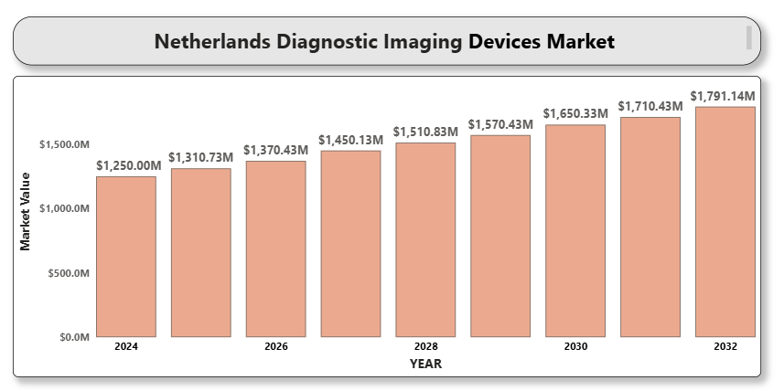

The market growth is driven by the increasing demand for early and accurate disease diagnosis, an aging population, and the rising burden of chronic diseases such as cancer and cardiovascular conditions. The adoption of advanced imaging technologies such as 3D/4D imaging, AI-assisted diagnostics, and portable imaging systems is transforming the clinical workflow across the Netherlands.

Government investments in healthcare infrastructure and digital health programs are supporting the integration of diagnostic imaging in both primary and tertiary care. The country’s focus on personalized and precision medicine has also increased the demand for high-resolution, real-time imaging modalities to facilitate targeted treatment planning and monitoring.

**Netherlands diagnostic imaging devices market Market Definition**

Diagnostic imaging devices are medical instruments used to generate visual representations of the interior of a body for clinical analysis and medical intervention. These include X-ray systems, MRI, CT, ultrasound, nuclear imaging, and mammography equipment. These devices play a critical role in disease detection, staging, and treatment assessment.

In the Netherlands, the healthcare system's strong emphasis on preventive care, patient safety, and early diagnosis is accelerating the deployment of non-invasive and technologically sophisticated diagnostic imaging solutions across hospitals and outpatient settings.

**Netherlands diagnostic imaging devices market Market Overview**

The Netherlands diagnostic imaging devices market is witnessing steady growth due to technological advancements and increasing healthcare spending. With a well-established healthcare infrastructure and high awareness among healthcare professionals, the country is at the forefront of implementing AI-based diagnostic tools and teleradiology services.

The rise in chronic and lifestyle-related diseases, coupled with the aging population, necessitates frequent imaging procedures, fueling market expansion. However, the high cost of advanced imaging systems and data privacy concerns associated with digital diagnostics pose challenges to market penetration.

Despite these hurdles, collaborations between public and private stakeholders, investments in research and innovation, and evolving reimbursement policies are expected to create new growth opportunities in the Dutch diagnostic imaging space.

**Netherlands diagnostic imaging devices market Market Segment Analysis**

**By Product Type**

* **X-ray Imaging Systems:** Widely used in orthopedic, dental, and chest diagnostics due to their speed and cost-efficiency.
* **Magnetic Resonance Imaging (MRI):** Preferred for soft tissue evaluation and neurological imaging due to high contrast resolution.
* **Computed Tomography (CT):** Vital for cross-sectional imaging, offering quick and detailed internal images.
* **Ultrasound Systems:** Portable and real-time imaging technology used extensively in obstetrics, cardiology, and emergency settings.
* **Nuclear Imaging:** Includes PET and SPECT systems used in oncology and cardiology for functional imaging.
* **Mammography:** Specialized for breast cancer screening and diagnostics, gaining traction with digital and 3D mammography systems.

**By End User**

* **Hospitals & Clinics:** Largest segment, driven by high imaging volume, integrated services, and availability of advanced technologies.
* **Diagnostic Imaging Centers:** Specialized facilities focusing on rapid, cost-effective imaging diagnostics.
* **Ambulatory Surgical Centers (ASCs):** Increasing adoption of mobile and compact imaging systems in outpatient surgery settings.

**By Portability**

* **Stationary Devices:** High-performance systems installed in fixed facilities such as hospitals and diagnostic centers.
* **Portable Devices:** Gaining momentum due to ease of transport, use in emergency settings, and home healthcare.

**Competitive Landscape**

The competitive landscape is characterized by the presence of leading global manufacturers and technology startups focusing on AI integration and workflow automation. Companies are engaging in partnerships with healthcare providers, investing in cloud-based imaging platforms, and developing next-gen imaging modalities to strengthen their position.

Pricing pressure, regulatory compliance, and customization to local healthcare needs are key factors influencing competition.

**Key Profiles of Netherlands diagnostic imaging devices market**

* Siemens Healthineers
* Koninklijke Philips N.V.
* A close-up of hands holding a tablet and a pen

  Description automatically generatedGE HealthCare
* Canon Medical Systems Corporation
* Fujifilm Holdings Corporation
* Samsung Medison Co., Ltd.
* Hologic, Inc.
* Carestream Health
* Shimadzu Corporation
* Esaote SpA
* Agfa-Gevaert Group
* Mindray Medical International Limited
* Neusoft Medical Systems
* Hitachi Healthcare (part of Fujifilm)
* Ziehm Imaging GmbH
* Butterfly Network, Inc.

**Key Developments**

* **in February 2024**, Eindhoven, Netherlands-based medtech company Scinvivo raised EUR 4.7 million (USD 5.03 million) in funding to disrupt bladder cancer diagnostics. Scinvivo technology applies optical coherence tomography (OCT) to enable high-resolution imaging of bladder tissue, which has the potential for enabling accurate minimally invasive procedures. The investment is a giant leap for Scinvivo and its disruptive technology for bladder cancer diagnostics.
* **In 2025** Philips' comprehensive IP portfolio benefits the Netherlands by enabling innovation by way of licensing or sale, helping new firms develop advanced diagnostic technologies. Notably, its ultrasound technology offers a less invasive, lower-cost alternative to CT or MRI, ideally suited for remote or inaccessible areas.

**Market Attractiveness**

The Netherlands diagnostic imaging devices market presents strong opportunities due to robust healthcare infrastructure, early adoption of digital technologies, and a growing elderly population. Supportive reimbursement schemes, government-backed innovation programs, and a focus on precision diagnostics further contribute to market expansion.

**Porter’s Five Forces Analysis**

* **Threat of New Entrants:** Moderate — Capital-intensive technologies and regulatory requirements pose entry barriers, though niche AI firms are emerging.
* **Bargaining Power of Suppliers:** Moderate — Few dominant suppliers of imaging components can influence pricing and availability.
* **Bargaining Power of Buyers:** High — Hospitals and procurement groups demand high-quality, cost-effective, and integrated imaging solutions.
* **Threat of Substitutes:** Low — Limited viable alternatives to advanced imaging for diagnostic accuracy.
* **Competitive Rivalry:** High — Driven by continuous innovation, strategic alliances, and global competition.

**Table of Contents**

1. **Introduction of Netherlands Diagnostic Imaging Devices Market**
   * 1.1 Overview of the Market
   * 1.2 Scope of Report
   * 1.3 Assumptions
2. **Executive Summary**
3. **Research Methodology**
   * 3.1 Data Mining
   * 3.2 Validation
   * 3.3 Primary Interviews
   * 3.4 List of Data Sources
4. **Netherlands Diagnostic Imaging Devices Market Outlook**
   * 4.1 Overview
   * 4.2 Market Dynamics
     + 4.2.1 Drivers
     + 4.2.2 Restraints
     + 4.2.3 Opportunities
     + 4.2.4 Trends
   * 4.3 Porter’s Five Forces Model
   * 4.4 Value Chain Analysis
5. **Market, by Product Type**
   * 5.1 X-ray Imaging Systems
   * 5.2 Magnetic Resonance Imaging (MRI)
   * 5.3 Computed Tomography (CT)
   * 5.4 Ultrasound Systems
   * 5.5 Nuclear Imaging
   * 5.6 Mammography
6. **Market, by End User**
   * 6.1 Hospitals & Clinics
   * 6.2 Diagnostic Imaging Centers
   * A close-up of hands holding a tablet and a pen

     Description automatically generated6.3 Ambulatory Surgical Centers
7. **Market, by Portability**
   * 7.1 Stationary Devices
   * 7.2 Portable Devices
8. **Competitive Landscape**
   * 8.1 Overview
   * 8.2 Company Market Ranking
   * 8.3 Key Development Strategies
9. **Company Profiles**

**9.1 Siemens Healthineers**  
9.1.1 Overview  
9.1.2 Financial Performance  
9.1.3 Product Outlook  
9.1.4 Key Developments

**9.2 Koninklijke Philips N.V.**  
9.2.1 Overview  
9.2.2 Financial Performance  
9.2.3 Product Outlook  
9.2.4 Key Developments

**9.3 GE HealthCare**  
9.3.1 Overview  
9.3.2 Financial Performance  
9.3.3 Product Outlook  
9.3.4 Key Developments

**9.4 Canon Medical Systems Corporation**  
9.4.1 Overview  
9.4.2 Financial Performance  
9.4.3 Product Outlook  
9.4.4 Key Developments

**9.5 Fujifilm Holdings Corporation**  
9.5.1 Overview  
9.5.2 Financial Performance  
9.5.3 Product Outlook  
9.5.4 Key Developments

**9.6 Samsung Medison Co., Ltd.**  
9.6.1 Overview  
9.6.2 Financial Performance  
9.6.3 Product Outlook  
9.6.4 Key Developments

**9.7 Hologic, Inc.**  
9.7.1 Overview  
9.7.2 Financial Performance  
9.7.3 Product Outlook  
9.7.4 Key Developments

**9.8 Carestream Health**  
9.8.1 Overview  
9.8.2 Financial Performance  
9.8.3 Product Outlook  
9.8.4 Key Developments

**9.9 Shimadzu Corporation**  
9.9.1 Overview  
9.9.2 Financial Performance  
9.9.3 Product Outlook  
9.9.4 Key Developments

**9.10 Esaote SpA**  
9.10.1 Overview  
9.10.2 Financial Performance  
9.10.3 Product Outlook  
9.10.4 Key Developments

**9.11 Agfa-Gevaert Group**  
9.11.1 Overview  
9.11.2 Financial Performance  
9.11.3 Product Outlook  
9.11.4 Key Developments

**9.12 Mindray Medical International Limited**  
9.12.1 Overview  
9.12.2 Financial Performance  
9.12.3 Product Outlook  
9.12.4 Key Developments

**9.13 Neusoft Medical Systems**  
9.13.1 Overview  
9.13.2 Financial Performance  
9.13.3 Product Outlook  
9.13.4 Key Developments

**9.14 Hitachi Healthcare (part of Fujifilm)**  
9.14.1 Overview  
9.14.2 Financial Performance  
9.14.3 Product Outlook  
9.14.4 Key Developments

**9.15 Ziehm Imaging GmbH**  
9.15.1 Overview  
9.15.2 Financial Performance  
9.15.3 Product Outlook  
9.15.4 Key Developments

**9.16 Butterfly Network, Inc.**  
9.16.1 Overview  
9.16.2 Financial Performance  
9.16.3 Product Outlook  
9.16.4 Key Developments

1. **Key Developments**
   * 10.1 Product Launches/Developments
   * A close-up of hands holding a tablet and a pen

     Description automatically generated10.2 Mergers and Acquisitions
   * 10.3 Business Expansions
2. **Appendix**
   * 11.1 Related Research